**Step:1**

**Create an analysis which contains two columns**

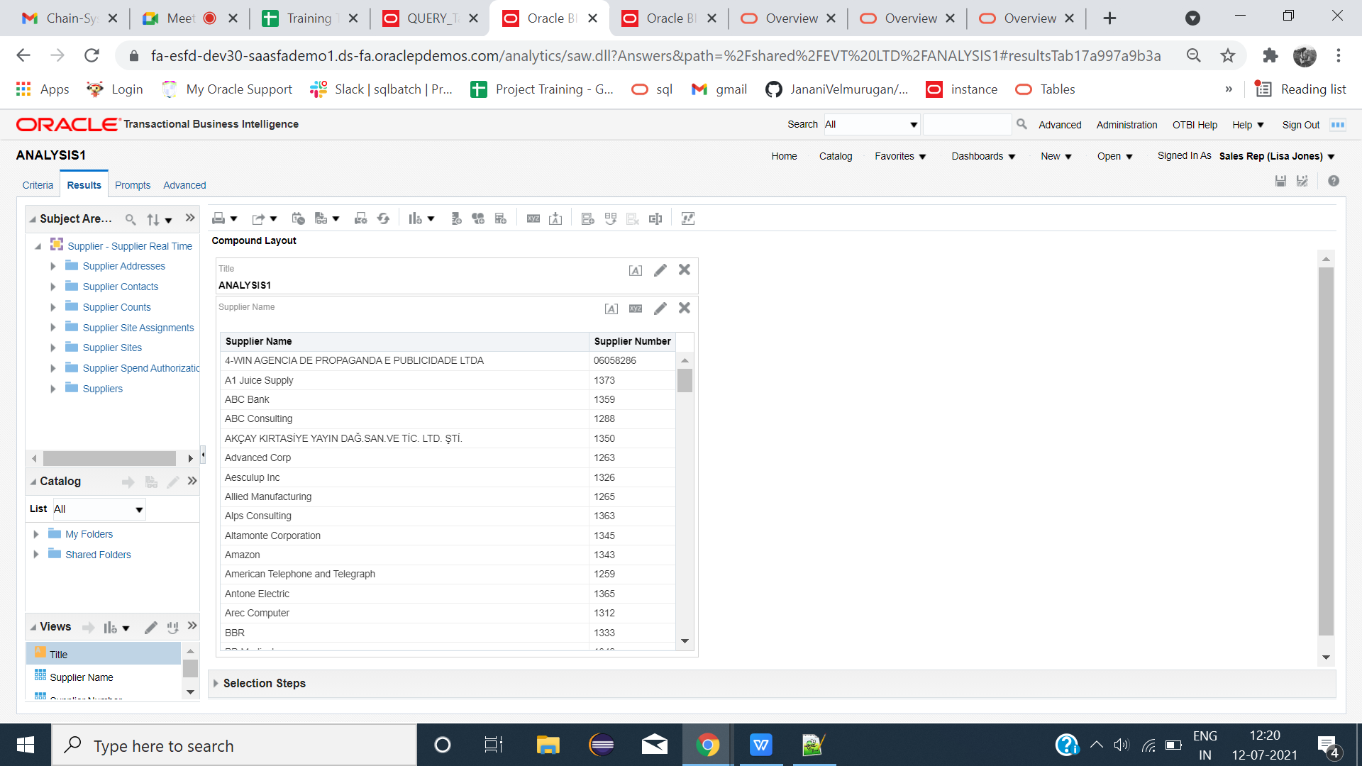

**Step:2**

**Create Two tables**

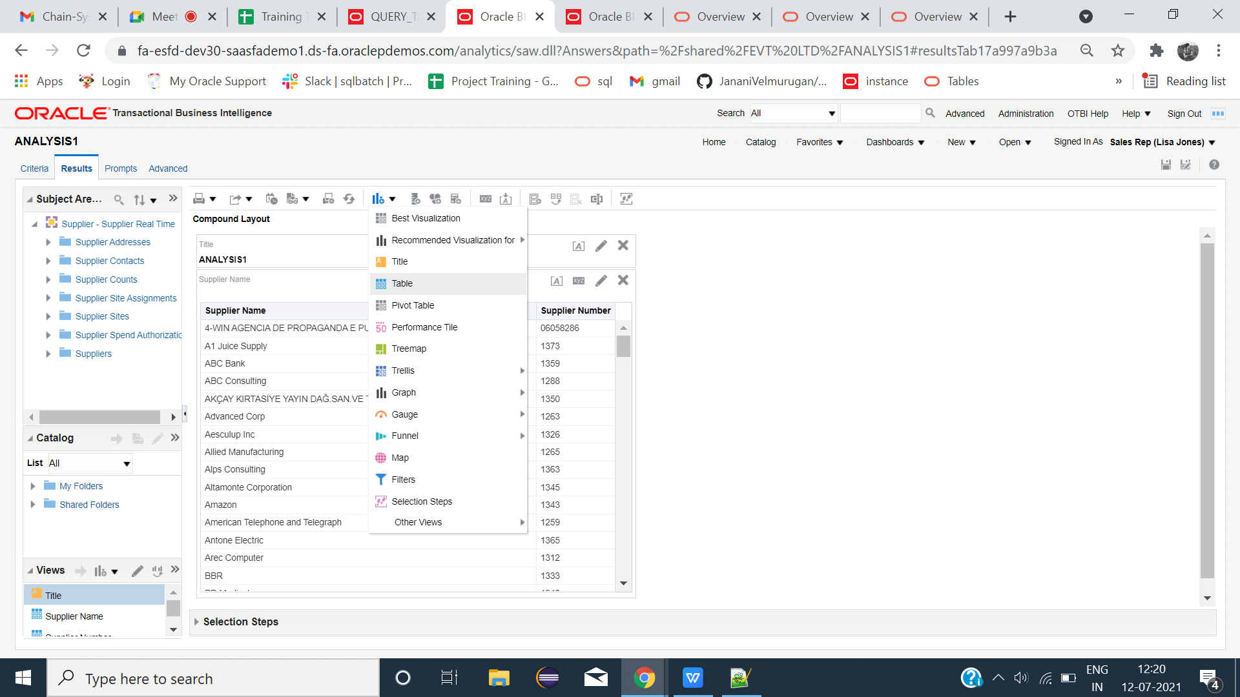

**Step:3**

**Drag unwanted column to excluded**

|  |  |
| --- | --- |
|  |  |

**Step:4**

**Rename the corresponding tables**

|  |  |
| --- | --- |
|  |  |

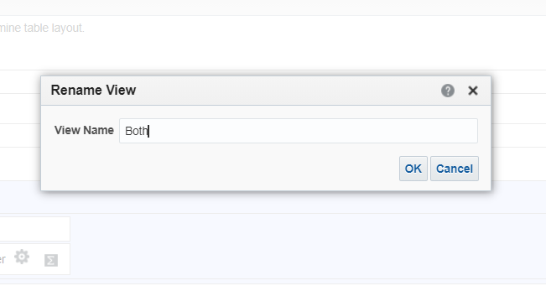

**Step:5**

**Click graph icon-->Other views-->View selector**

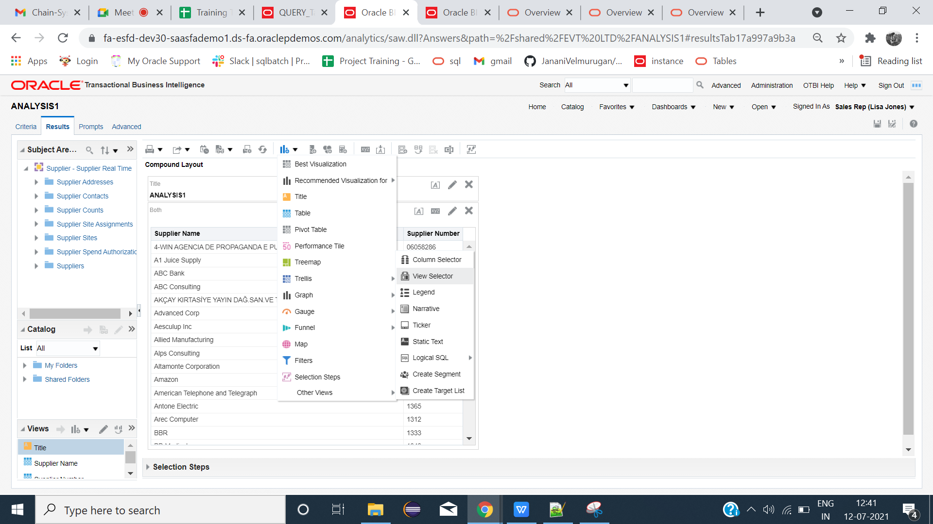

**Step:6**

**Insert the needed tables name-->Done**

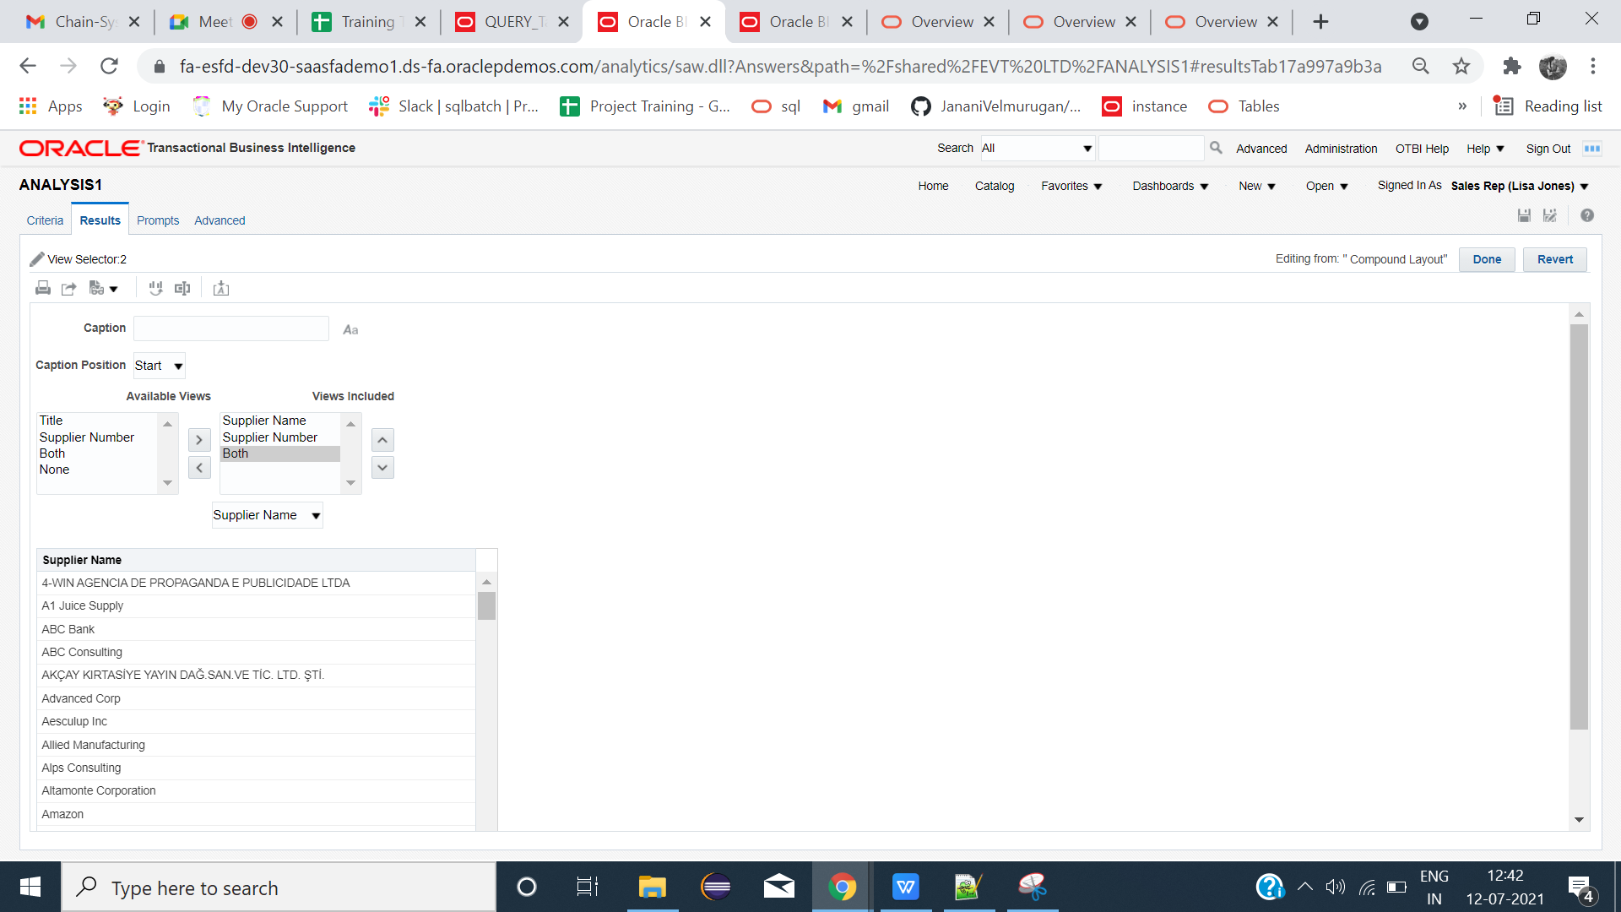

**Step:7**

**Remove first three tables from results except view selector**

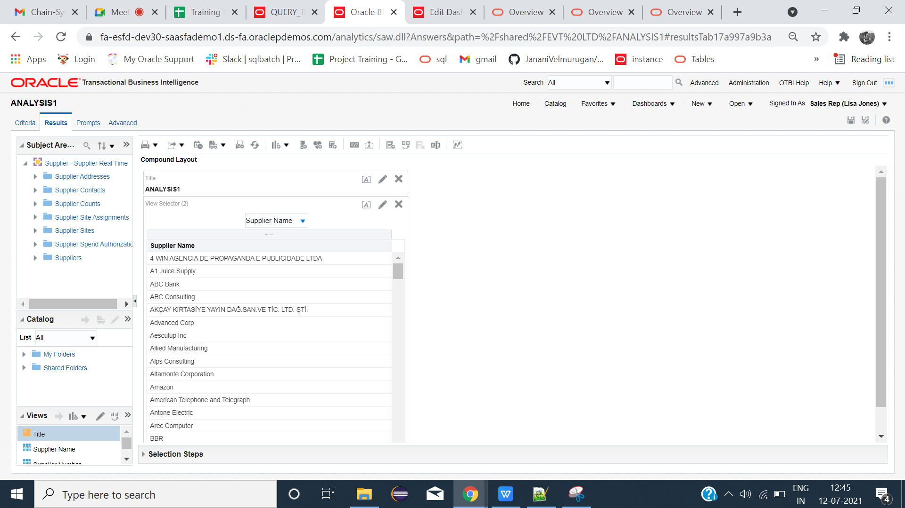

**Step:8**

**Create dashboard and insert the analysis-->save-->Run**

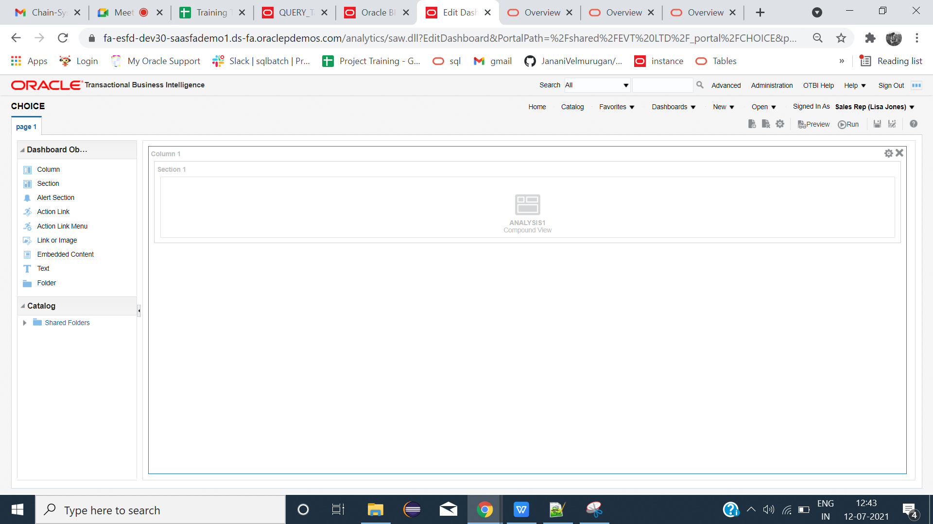

**OUTPUT:**

**Select the needed tables**

